|  |
| --- |
| EPAM Systems, RD Dep. |
| Philip Morris International DWH |

Image goes here.

Contents

1. Business Description 3

1.1. Business background 3

1.2. Problems because of poor data management 3

1.3. Benefits from implementing a Data Warehouse 3

2. Dimensions of a Business 3

3. Logical Scheme 3

4. Data Flow 3

5. Fact Table Partitioning Strategy 3

6. Strategy of Parallel Load 3

7. Report Layouts 3

# Business Description

## Business background

## Philip Morris International Inc. (PMI) (NYSE: PM) is an American global cigarette and tobacco company, with products sold in over 180 countries outside the United States. The most recognized and best selling product of the company is Marlboro.

The company's operational headquarters are in Lausanne, Switzerland, although the corporate headquarters remain in New York. It does not operate in the United States, with Philip Morris brands there still owned by PMI's former owner Altria.

Because tobacco, the main constituent of cigarettes, is the single greatest cause of preventable death globally[3] and is addictive, the company's operations (and its competitors') are highly controversial and are increasingly the subject of litigation and restrictive legislation from governments concerned about the health impacts of its products.

Philip Morris International has six multi-billion US$ brands including:

1. Dji Sam Soe 234 was launched in 1913 and is a brand of Kretek cigarettes. It is the best seller of Kretek cigarettes in Indonesia.

2. L&M was launched by Liggett & Myers in 1953 with the tagline: "American cigarettes of the highest quality with the best filter." L&M variants include full flavor shorts, full flavor 100s, lights, ultra lights, menthol shorts, menthol 100s, menthol light shorts, menthol light 100s, Turkish Blend shorts, Turkish Blend 100s, and L&M Mild Kretek.

3. Longbeach include in Australia and Indonesia in 1999. Longbeach variant include: Longbeach Filter and Longbeach Mild.

4. Marlboro was launched in 1904. Marlboro is the premium brand. Marlboro variants include: Marlboro Special, Marlboro Menthol, Marlboro Lights, Marlboro Lights Menthol, Marlboro Mix-9 Filter Kretek, Marlboro Flavor Plus, Marlboro Black Menthol, and Heatsticks, a heated tobacco product.[10]

5. ST Dupont Paris is the brand cigarette designed by Simon Tissot Dupont in 1902. With the black packaging. ST Dupont Paris variants include: filter, lights, menthol, and menthol lights.

6. U Mild was launched in Indonesia in May 22, 1998 after Indonesian revolution. U Mild is a Mild Kretek cigarette sold in Indonesia.

In the end of 2016 Philip Morris presented the new product called IQOS - smokeless cigarette–one of the latest products from Philip Morris International, manufacturers of the legendary Marlboro cigarettes. The product is a hybrid between the benefits of electronic cigarettes and the design of traditional types – making it perfect for smokers looking to switch to vaping or even for occasional use. Given the known dangers of smoking traditional cigarettes, switching to vaping or just implementing a sporadic alternative is a good option.

The iQOS uses refills of real tobacco, but doesn’t burn it like the conventional cigarette which prevents the ingestion of combustive, charred materials. Rather, the iQOS ecig heats the tobacco just prior to the point of combustion, producing tobacco-flavored vapor.

## Problems because of poor data management

A brand new product (iQOS) appeared in the last year, but due to the poor management, it didn’t get much popularity worldwide. As a result new production items had produced very little profit compared to the forecasts and the amount of resources that was spent on its production. All of this caused financial problems of the company and damaged the economic policy in 2017.

## Benefits from implementing a Data Warehouse

So as to recover the company’s brand name, the board of directors decided to build a detailed plan of the economic situation on the current date and to provide detailed information about all products and its sales amounts along with new company’s production items. The main goal of this research is to get proper information about popularity and economic profitability of new products. Another task is to gather information about “old” production items. The research should be based on prebuild Data Warehouse.

# Dimensions of a Business

Starting with identifying 4 steps of creating data warehouse

1. Select the business process

Getting detailed information about brand-new product contribution to the company’s production process

2. Declare the Grain

Total sales and quantity amount of new products compared

3. Identify the Dimensions

1. Products;
2. Departments;
3. Consumers;
4. Time;
5. Promotion

4. Identify the Facts

* “Total sales amount” as FACT_SALES

Entities:

**Product Category**

* Categories of the products

Examples: cigarette, tobacco heating products, vapor products

**Product**

* Brands, produced by PMI company

Examples: Marlboro, Most popular product of the company, global,

**Location**

* Addresses, cities, countries and regions

Example: 10-3 Hyde Park, NY, USA, North America

**Consumers**

* Consumers of the PMI products

Examples: Japan retail agency

**Price index**

* Price index related to appropriate country. Prices of PMI products vary for different countries and each country has it’s index depending on which, the prices are set.

Example: Russia Price Index 1.3, USA Price Index 1.7

**Departments**

* PMI agency all over the world

Example: St.Petersburg Main Agency, 2201

**Promotions**

* Promotions, which take place in some parts of the year

Example: Promotion #276421 Brand-new product

**Sale**

* Sale of some product to the customer

Example: PRODUCT, PRICE, QUANTITY, CONSUMER, DEPARTMENT, DATE

As a result, we get such dimensions:

|  |  |  |  |
| --- | --- | --- | --- |
| **Dimension/Fact** | **Field** | **Description** | **Note** |
| **Products** | Product_ID | autoincrement |  |
| Product_Name | Product name |  |
| Product_Category | Category of product |  |
| Product_Type | Type of product | [standard/slim/...] |
| Product_Description | Product description |  |
| Product_Package_Size | Size of package |  |
| Product_Package_Color | Color of package |  |
| Product_Item_Size | Product_Item size |  |
| Product_TobaccoPerItem | Amount of tobacco in one product item | '99' if no tobaco |
| Product_ItemsInPackage | Amount of items In one package |  |
| Product_Image | Image of product |  |
| Localization | Localization of product | global/local |
| Std_Price | Standard price for product item without price index |  |
| **Departments** | Department_ID | autoincrement |  |
| Department_Code | natural key |  |
| Department_Description | Description of department |  |
| Department_Address | Address |  |
| Department_City | City |  |
| Department_Country | Country |  |
| Department_Region | Region |  |
| **Consumers** | Consumer_ID | autoincrement |  |
| Consumer_TITLE | Name of agency/department/employee |  |
| Address | Address |  |
| City | City |  |
| Country | Country |  |
| Region | Region |  |
| Postal_Code | Postal Code |  |
| Phone | Consumer phone number |  |
| Price_Index | Price index for a consumer | depends on the location country |
| **Time** | Time_ID | natural key |  |
| Day_in_month |  |  |
| Day_in_week |  |  |
| Day_in_year |  |  |
| Day_Name |  |  |
| Week_in_month |  |  |
| Month_in_year |  |  |
| Month_Name | Name of month | [January] |
| Quarter |  | [Q2] |
| Year |  |  |
| **Promotion** | Promo_ID | autoincrement |  |
| Promo_Name | Name of promotion |  |
| Promo_Desc | Description of promotion |  |
| Promo_Begin_Date | Start date of promotion |  |
| Promo_End_Date | End date of promotion |  |
| Promo_Cost | Cost of promotion |  |

**Fact Table**

**Fact_Sales**

|  |  |  |  |
| --- | --- | --- | --- |
| **Dimension/Fact** | **Field** | **Description** | **Note** |
| **FACT_SALES** | PRODUCT_ID | Foreign Key |  |
| DEPARTMENT_ID | Foreign Key |  |
| CONSUMER_ID | Foreign Key |  |
| TIME_ID | Foreign Key |  |
| PROMO_ID | Foreign Key |  |
| SALE_AMOUNT | Amount of sale |  |
| QUANTITY | Quantity of product per sale |  |

As a result we get star schema for the PMI Data Warehouse:

**Star schema:**

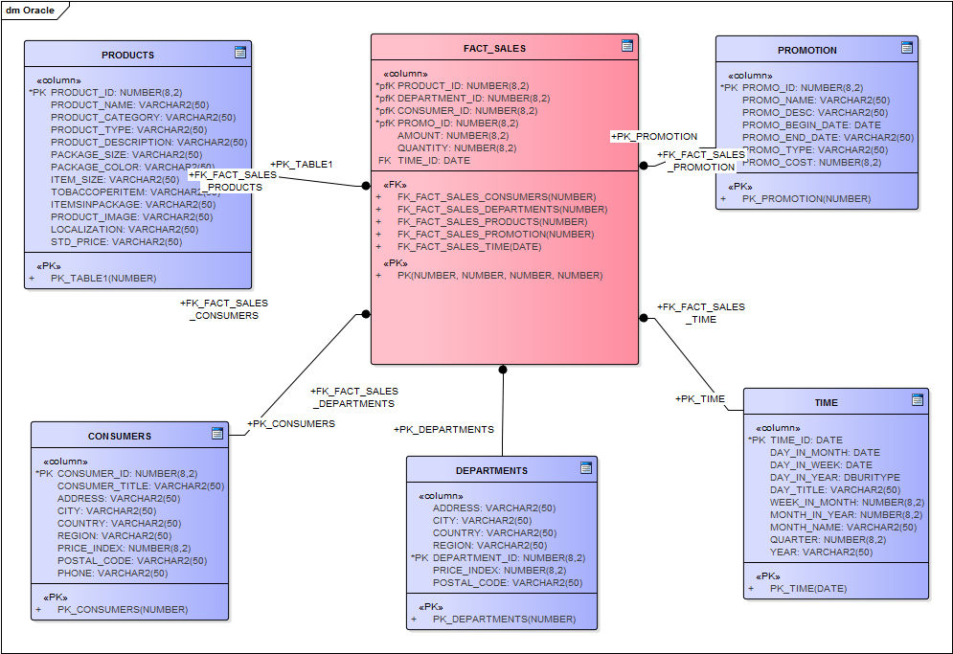

**Methods, rules and the process of generation of source data are the following:**

* Product description and whole information will be taken from the PMI website and Wikipedia;
* Information about departments will be taken from additional sources, which provide appropriate information about PMI deps;
* Prices for products will be taken from the source <https://www.numbeo.com/cost-of-living/prices_by_country.jsp?displayCurrency=USD&itemId=17> where there is an information about pricing in different countries. Other product pricing will be generated on the basis of this source so as to provide approximately true information about different brands of PMI;
* Pricing Index will be set up for location on the basis of source above;
* Data on different years will be generated manually;
* Data on amount of sales will be generated manually (within the framework of global brand share);
* Data on quantity of products sold will be generated manually (within the framework of global brand share).